
RAMAIAH
Institute of Technology
USN | 1 | M | S

(Autonomous Institute, Affiliated to VTU)
(Approved by AICTE, New Delhi & Govt. of Karnataka) Accredited by NBA & NAAC with ‘A’ Grade

SEMESTER END EXAMINATIONS – JANUARY 2019

Course & Branch | : | B.E : Computer Science and Engineering | Semester | : | V
Subject | : | Computer Networks | Max. Marks | : | 100
Subject Code | : | CS53/CS1553 | Duration | : | 3 Hrs

Instructions to the Candidates:
- Answer one full question from each unit.
- Write figures wherever necessary.

 |  | UNIT- I
1. | a) | Compare persistent and non-persistent TCP connections that are used to configure HTTP clients and servers. | CO1 | (06)
 | b) | Explain file distribution using BitTorrent with an example. | CO1 | (06)
 | c) | Consider distributing a file of F = 15 Gbits to 1000 peers. The server has an upload rate of U_{s} = 30 Mbps, and each peer has a download rate of d_{i} = 2 Mbps and an upload rate of u=700 Kbps. Compute the minimum distribution time for P2P. | CO1 | (08)
2. | a) | Explain the services provided by DNS. Discuss the problems involved in centralized design of DNS. | CO1 | (08)
 | b) | Differentiate between POP3 and IMAP. | CO1 | (06)
 | c) | Discuss the problems involved in circular DHT and explain how this problem can be solved with an example. | CO1 | (06)
 |  | UNIT– II
3. | a) | What is meant by piggybacking? Draw neat sequence diagram to show the sequence and acknowledgement numbers for telnet applications over TCP. Suppose Host A sends two TCP Segments back to back to Host B over a TCP Connection. The First segment has sequence number 90 and the second has the sequence number 110.  i. How much data is in the first segment?  ii. Suppose that the first segment is lost but the second segment arrives at B. In the acknowledgement that Host B send to Host A, what will be the acknowledgement number? | CO2 | (08)
 | b) | What is meant by fairness in TCP? With an example explain how two TCP connections share single bottleneck link. What are the problems in sharing? | CO2 | (06)
 | c) | Illustrate TCP slow start method with neat figure. | CO2 | (06)
4. | a) | Draw the TCP segment structure and discuss the use of the following flags of TCP segment:  - PUSH ii) URG iii) SYN iv) RST. | CO2 | (06)
 | b) | Describe why an application developer might choose to run an application over UDP rather than TCP | CO2 | (06)
 | c) | Write an algorithm for TCP sender showing three major events related to data transmission and retransmission. | CO2 | (08)
 |  | UNIT- III
5. | a) | Explain Dijkstra's algorithm. Solve the following using the same.  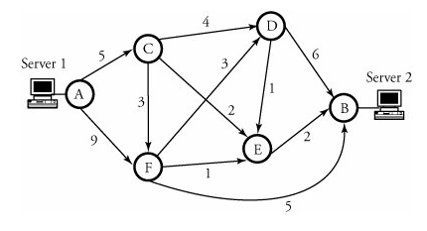 | CO3 | (10)
 | b) | An organization is granted a block of addresses with the beginning address 5.6.4.0/24. The organization needs to have 3 subblocks of addresses to use in its three subnets: one subblock of 9 addresses, one subblock of 62 addresses, and one subblock of 123 addresses. Design the subblocks. | CO3 | (06)
 | c) | Explain IP packet fragmentation and reassembly. | CO3 | (04)
6. | a) | Explain Bellman-Ford algorithm. Solve the following using the same.  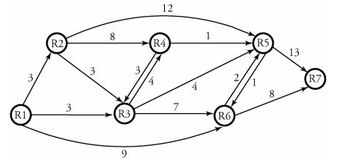 | CO3 | (10)
 | b) | Consider a router that interconnects three subnets: Subnet 1, Subnet 2, and Subnet 3. Suppose all of the interfaces in each of these three subnets are required to have the prefix 223.1.17/24. Also suppose that Subnet 1 is required to support at least 60 interfaces, Subnet 2 is to support at least 90 interfaces, and Subnet 3 is to support at least 12 interfaces. Design the subblocks. | CO3 | (06)
 | c) | Explain any two ways of transitioning from IPv4 to IPv6 network. | CO3 | (04)
 |  | UNIT- IV
7. | a) | Explain with neat figure the steps involved when a base station with common MSC decides to hand off its mobile user. | CO4 | (08)
 | b) | Discuss IGMP protocol with the help of IGMP packet format. | CO4 | (08)
 | c) | What is advantage of using sparse mode shared tree over dense mode source based tree. | CO4 | (04)
8. | a) | Discuss the efficiency of MOSPF in detail. | CO4 | (06)
 | b) | Write an algorithm for protocol independent multicast routing. | CO4 | (06)
 | c) | Describe the role of the beacon frames in 802.11. Write the advantages and disadvantages of cellular system. | CO4 | (08)
 |  | UNIT- V
9. | a) | Compare and contrast Leaky-Bucket and Token-Bucket approaches. | CO5 | (05)
 | b) | Estimate the Jitter at receiver in Real-Time Traffic considering various parameters (Timestamp of the RTP data packet, arrival time, and Measure of difference between interarrival time of RTP packets at receiver and the one for packet departure from the source) at the receiver. Two voice sources come to one server for live transmission together, using RTP packets. Each source bandwidth has been compressed to 31 Kb/s. Show an overview of the encapsulated RTP/IP datagram, and estimate the size of each packet, utilizing an RTP packet using UDP. | CO5 | (08)
 | c) | Discuss the Differentiated Services approach to provides a simpler and more scalable QoS with neat diagram. | CO5 | (07)
10. | a) | Discuss Resource Reservation Protocol (RSVP) that is typically used to provide real-time services over a connectionless network with packet scheduling. Each output port processor unit of a router has four inputs designated to four different flows. The unit receives the packets in the following order during a period in which the output port is busy but all queues are empty. Give the order in which the packets are transmitted assuming a fair queuing scheduler.  Flow:1, 1, 1, 1, 1, 1, 2, 2, 3, 3, 3, 4  Packet: 1, 2, 3, 4, 5, 6, 7,8, 9, 10, 11, 12  Packet size: 110, 110, 110, 100, 100, 100, 100, 200, 200, 240, 240, 240 | CO5 | (08)
 | b) | Show the placement of VoIP in the five-layer TCP/IP model and discuss its main protocols with corresponding layers of operation. | CO5 | (06)
 | c) | Discuss the structure of packets in the stream control transmission protocol (SCTP). | CO5 | (06)

****************

